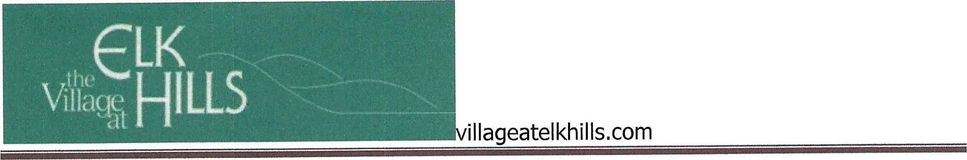

Village at Elk Hills HOAI

Annual Meeting of the Board

May 31, 2023 

Minutes

Missoula Alliance Church, 100 East Foss Court, Room 100, Missoula, MT

1. Call to Order and Determination of Quorum: **Due to the fact that there was not enough representation from unit owners to constitute a quorum, the meeting was adjourned. Election ballots will be sent out by mail.**